**Fetal AI: Using ML to Predict & Monitor Fetal Health**

TEAM NUMBER - 252

TEAM MEMBERS:

VISHAL JA 20BDS0289

BVS PRIYANKA 20BDS0237

EDIL AUXILLEA A 20BDS0393

YASH JEENA 20BCT0227

**1. INTRODUCTION**

**1.1 Overview**

The main goal of the "Fetal AI: Using Machine Learning to Predict and Monitor Fetal Health" project is to create an intelligent system that makes use of machine learning methods to predict and track a fetus's health throughout pregnancy. The majority of fetal health monitoring currently uses traditional techniques like ultrasound and periodic examinations. Even if these techniques are efficient, they might not offer constant and real-time monitoring, which is essential for quickly recognizing and controlling unexpected risks that arise.  In order to help their decision-making processes, provide pregnant women with personalized treatment, healthcare professionals, including obstetricians and paramedics, could utilize the proposed solution.  The proposed solution involves analyzing various physiological parameters and data collected from pregnant women. By developing a predictive model using these data, healthcare professionals can have a tool that aids in the early identification of fetal health issues. This solution has the potential to complement existing monitoring methods and improve overall prenatal care.

The project will involve several stages, including data collection, preprocessing, feature engineering, model selection, training, and evaluation. Relevant datasets and medical records will be utilized to train and validate the predictive models. The models will be fine-tuned to achieve optimal performance and accuracy. The development of this project requires a combination of hardware and software components. A computer system capable of running machine learning algorithms and handling data processing tasks is essential. Programming languages such as Python, along with libraries like Panda, Numpy, Seaborn, and Scikit-Learn, will be used to implement the machine learning algorithms.  The project's success will rely heavily on the availability of accurate and comprehensive input data. The output of the project will be a predictive model capable of analyzing the input data and providing valuable insights into fetal health. The model's predictions can assist healthcare professionals in making informed decisions and taking necessary interventions to ensure the well-being of the fetus.

**1.2 Purpose**

* **Early Complication Detection:** By monitoring biological signs, the initiative offers early detection of potential fetal health concerns, allowing for earlier treatments and better results for both the mother and the fetus.
* **Real-time Monitoring:** Continuous observation of fetal health gives medical practitioners the most recent information to track the fetus's health and enables preventive action to be taken in the event of any issues.
* **Personalized Care:** The project improves the standard of prenatal care by utilizing machine learning algorithms to provide personalized care by analyzing individual data to produce specific recommendations and actions based on each pregnancy's particular characteristics.

* **Better Decision-Making:** By studying vast data and delivering insightful recommendations for the most suitable course of action for the best possible maternal and fetal health, the predictive models help healthcare professionals make well-informed decisions.
* **Enhanced Prenatal Care:** By combining conventional approaches with cutting-edge predictive models, the implementation of machine learning capabilities into current healthcare systems improves prenatal care. This leads to more precise and proactive care, better results, and higher patient satisfaction.

**2. LITERATURE SURVEY**

**2.1 Existing problem**

The fetal health situation in India and globally is a significant and the most critical problem in the medical field. In India, there are many challenges such as limited access to quality prenatal care, high maternal and infant mortality rates, and prevalence of nutritional deficiencies that contribute to adverse fetal health outcomes. Issues such as low birth weight, premature births, and congenital anomalies pose risks to the well-being of fetuses. Maternal health conditions like anemia, hypertension, gestational diabetes, and infections further exacerbate the situation. Inadequate awareness, cultural beliefs, and resource constraints in rural areas compound the challenges. Similarly, across the globe, fetal health varies, with disparities based on access to healthcare, socioeconomic factors, and racial and ethnic backgrounds.

Fetal health monitoring traditionally relies on periodic check-ups and ultrasound scans, which may not provide real-time and continuous insights into the well-being of the fetus. Early detection of potential complications and personalized care based on individual data are limited, leading to suboptimal outcomes and challenges in proactive intervention.  Conventional methods like ultrasound imaging, maternal health assessments, and periodic physical examinations have provided valuable insights but are limited in terms of real-time monitoring, accurate prediction, and personalized care. They often rely on manual interpretation and lack the ability to leverage advanced data analysis techniques.

**2.2 Proposed solution**

The proposed solution is to employ machine learning algorithms and data analysis techniques to develop a predictive model that can continuously monitor and predict fetal health based on physiological parameters and medical data. This AI-based approach utilizes a comprehensive dataset, including ultrasound measurements, maternal health records, and other relevant data points, to train the model. The developed predictive model makes use of cutting-edge machine learning methods to uncover trends and connections in the dataset. It uses feature engineering approaches to identify the most useful features for precise predictions and extract meaningful information from the gathered data. Using accessible data, the model is trained and verified, establishing its performance and robustness.  By utilizing this proposed solution, healthcare professionals can benefit from early detection of potential complications, continuous real-time monitoring, personalized care recommendations, and improved decision-making based on accurate predictions.

**3. THEORETICAL ANALYSIS**

**3.1 Block diagram**

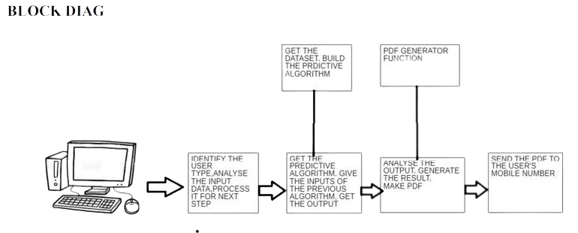

**3.2 Software designing**

* Data preprocessing tools for cleaning, transforming, and feature engineering the collected data.
* Machine learning frameworks or libraries for model training and prediction.
* Development environments for implementing the Fetal AI system, such as Python programming language and relevant libraries like numpy, matplotlib, pandas and seaborn.
* User interface design tools for creating an intuitive and interactive interface for healthcare professionals.

**4. EXPERIMENTAL INVESTIGATIONS**

During the experimental investigations of this project, several analyses and investigations were conducted to refine and evaluate the solution. These investigations aim to assess the performance, accuracy, and effectiveness of the developed predictive models. Here are some key points regarding the experimental investigations:

* **Data Preprocessing Analysis:** Extensive analysis is performed on the collected data to identify any outliers, missing values, or data inconsistencies. Techniques like data imputation, outlier detection, and feature selection are applied to ensure data quality and reliability for subsequent model training and evaluation.
* **Feature Importance Analysis: I**nvestigate the significance of features in predicting fetal health. Employ statistical methods and correlation analysis to identify informative features that contribute significantly to accurate predictions.
* **Model Selection and Comparison:** Evaluate multiple machine learning algorithms to select the most suitable model. Compare their performance using metrics like accuracy, precision, recall, and F1 score to choose the model with the highest predictive capability.
* **Model Training and Validation:** Train the selected model using preprocessed data, employing strategies like hyperparameter tuning for optimal performance. Validate the trained model using separate datasets or cross-validation techniques to assess its ability to generalize and perform well on unseen data.
* **Performance Evaluation:** Assess the performance of the model using evaluation metrics like confusion matrix, ROC curve, and precision-recall curve. These metrics provide insights into the model's accuracy and its ability to correctly predict different classes of fetal health outcomes.
* **Comparative Analysis with Existing Methods:** Compare the AI-based approach with conventional methods like ultrasound to evaluate its superiority, efficiency, and effectiveness. Analyze the project's early detection and real-time monitoring capabilities to assess its advantages over traditional methods.
* **Sensitivity Analysis**: Investigate the impact of variations in input features on the model's predictions. Conduct sensitivity analysis to understand the model's robustness and stability, gaining insights into the factors that influence fetal health outcomes.
* **Interpretability and Explainability Analysis:** Enhance the interpretability of predictive models by employing techniques like feature importance analysis and SHAP values. Analyze these factors to understand and explain the rationale behind the model's predictions, improving transparency and trustworthiness for healthcare professionals.

**5. FLOWCHART**

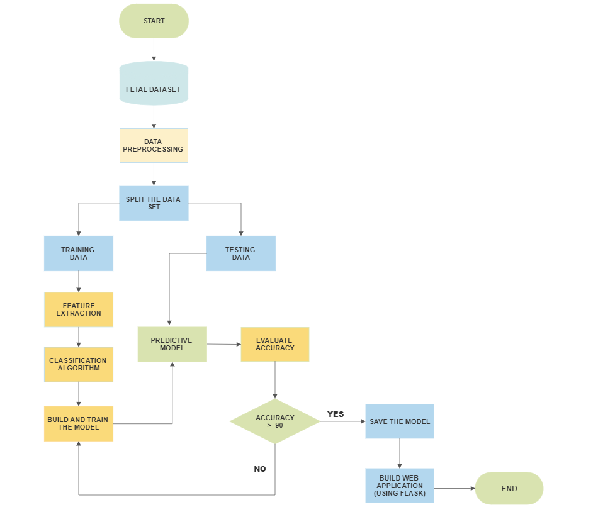

**6. RESULT**

We have developed a comprehensive website that enables users to input various

measurements related to fetal decelerations, uterine contractions, fetal movements, and

more. The website utilizes advanced machine learning algorithms to analyze these inputs

and provide an assessment of the fetal health status. By incorporating a user-friendly

interface, healthcare professionals and expectant parents can easily enter the necessary

data for evaluation. The algorithms leverage the power of data-driven insights to determine

whether the fetus is in a healthy state or if there are any potential concerns. This innovative

approach to fetal health monitoring offers a reliable and convenient solution for assessing

the well-being of the fetus, empowering users to make informed decisions and take

appropriate actions based on the results provided by the website.

**TEST CASE 1:**

**USER INPUTS**

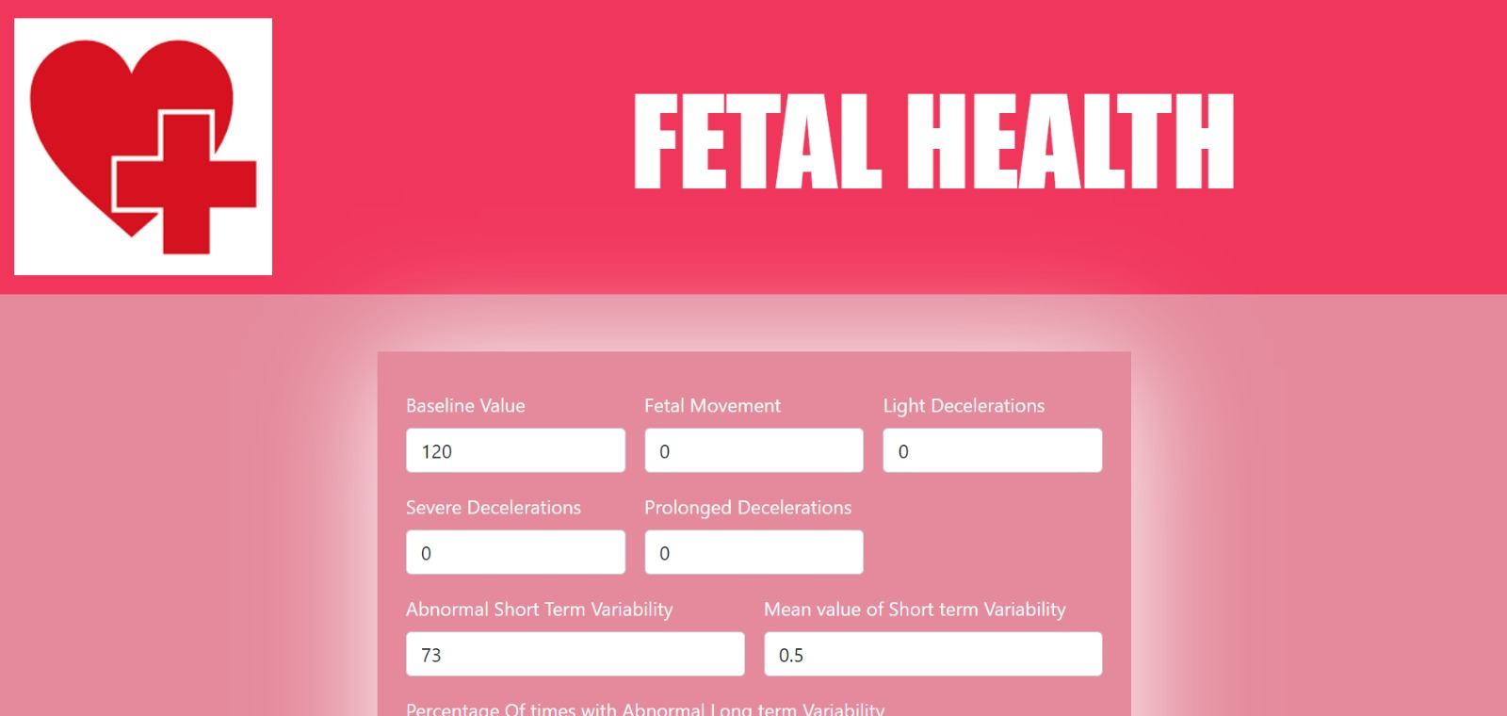

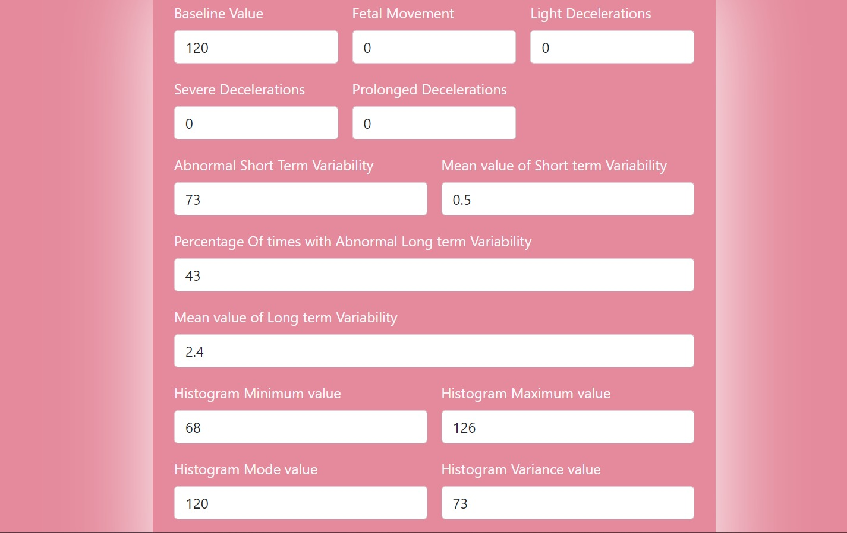

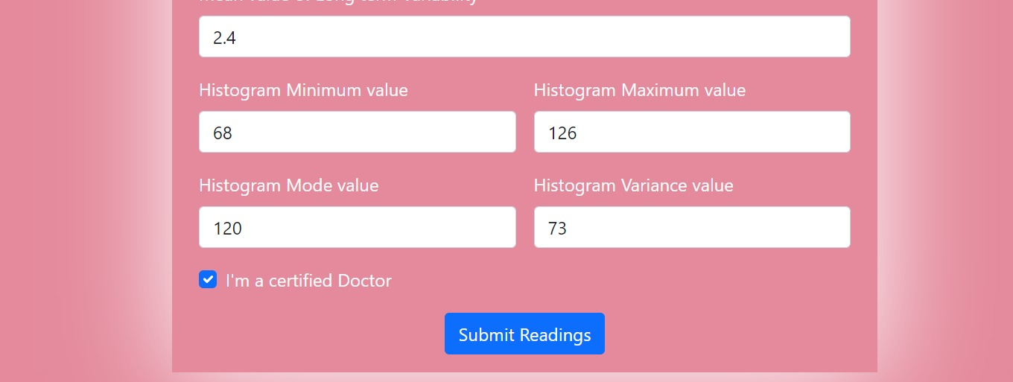

**OUTPUT: HEALTH CONDITION OF THE FETUS**

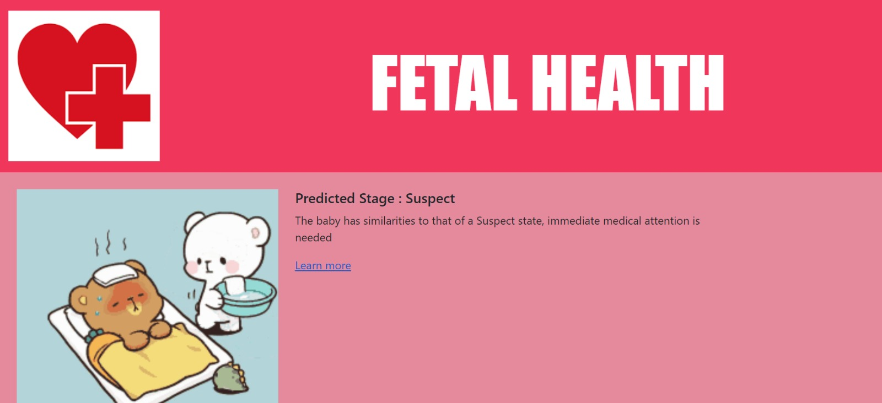

**REPORT ON POTENTIAL CAUSES FOR THE FETAL HEALTH CONDITION**

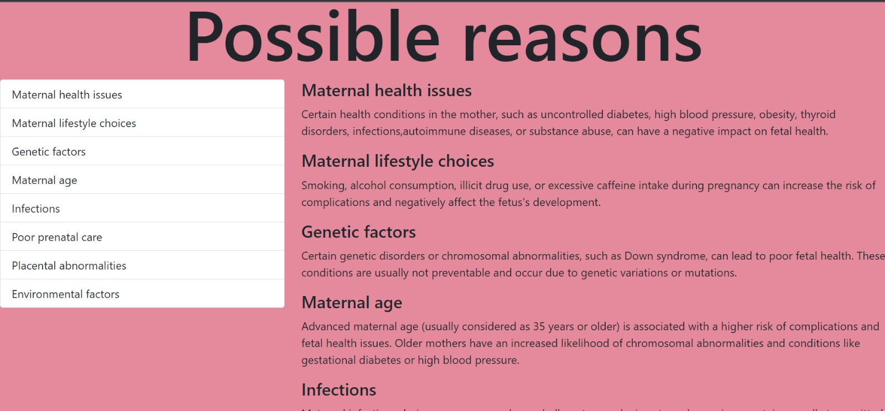

**TEST CASE 2**

**USER INPUTS**

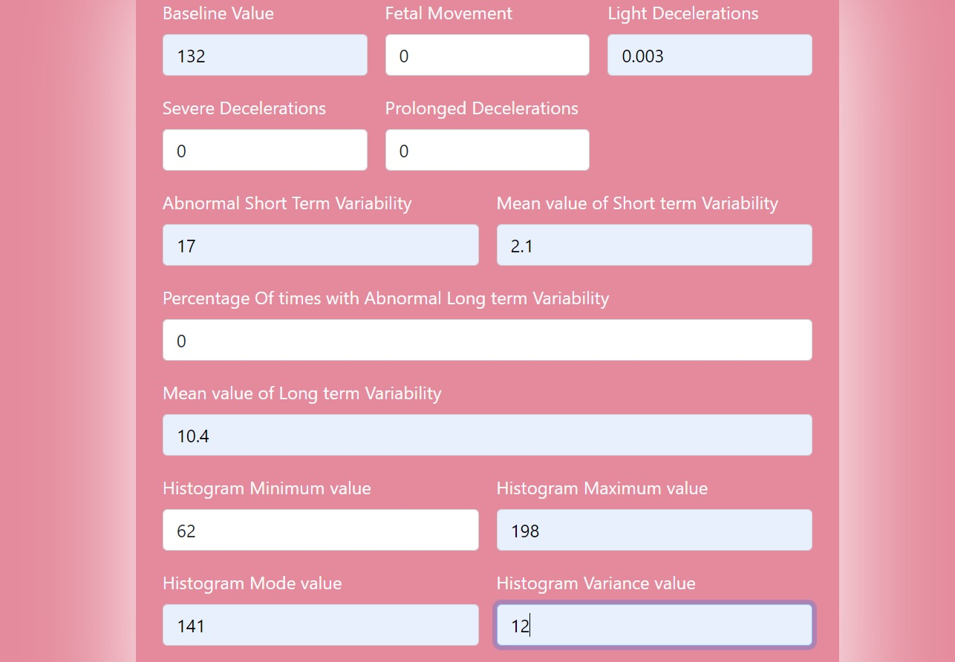

**OUTPUT: HEALTH CONDITION OF THE FETUS**

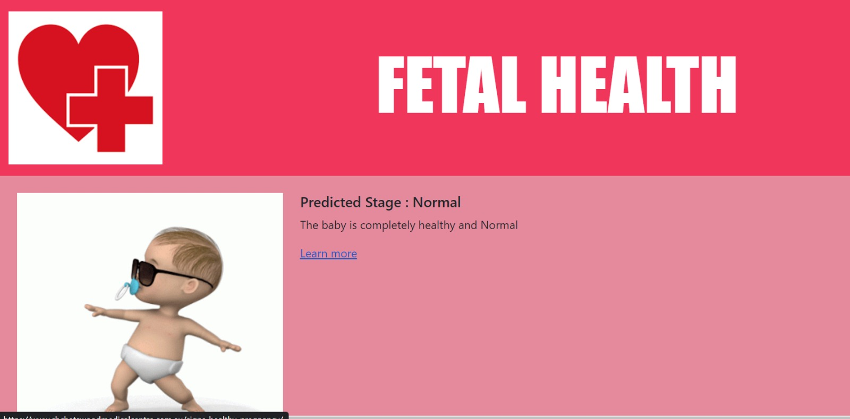

**REPORT ON POTENTIAL CAUSES FOR THE FETAL HEALTH CONDITION**

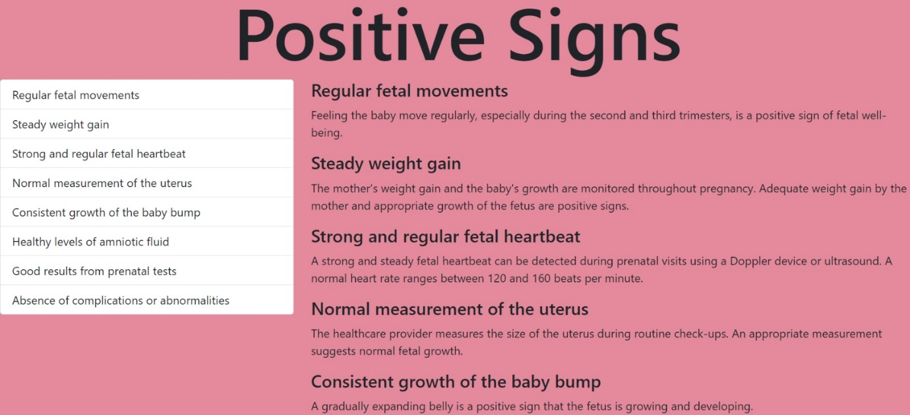

**7. ADVANTAGES & DISADVANTAGES**

ADVANTAGES

* **Improved Accuracy:** Fetal AI leverages machine learning algorithms to enhance the accuracy of fetal health prediction and monitoring, reducing the potential for human error in traditional methods.
* **Comprehensive Analysis:** By integrating multiple data sources, Fetal AI offers a comprehensive analysis of fetal well-being, considering various factors such as ultrasound measurements, maternal health records, and fetal heart rate.
* **Decision Support:** Fetal AI assists healthcare professionals in making informed decisions by providing predictive analytics and actionable insights about fetal health.
* **Potential for Early Intervention:** Early detection of potential complications through Fetal AI can lead to timely interventions, improving outcomes for both pregnant individuals and their unborn babies.
* **Personalized Care:** Fetal AI can aid in tailoring healthcare plans to individual patients by considering their specific risk factors and optimizing care accordingly.
* **Scalability:** The proposed solution can be scaled to accommodate larger datasets and be integrated into existing healthcare systems, potentially benefiting a larger population.

DISADVANTAGES:

* **Data Availability:** The accuracy and performance of Fetal AI heavily depend on the availability of high-quality and diverse datasets. Limited or biased data could impact the system's effectiveness.
* **Technical Challenges:** Implementing and maintaining Fetal AI may pose technical challenges, including data integration from different sources, model training, and ongoing system updates.
* **Ethical Considerations:** The use of AI in healthcare raises ethical concerns regarding privacy, data security, informed consent, and potential biases in decision-making. Safeguards and regulatory measures must be in place to address these concerns.

**8. APPLICATIONS**

* **Fetal Health Monitoring:** Fetal AI can assist healthcare professionals in monitoring fetal health parameters and detecting abnormalities in real-time, enabling early intervention and improved outcomes.
* **High-Risk Pregnancy Management:** Fetal AI can be particularly beneficial in managing high-risk pregnancies, where continuous monitoring and timely interventions are crucial.
* **Antenatal Care Optimization:** Fetal AI can help optimize antenatal care plans by providing personalized risk assessments, facilitating early detection of complications, and guiding treatment strategies.
* **Decision Support System:** Fetal AI can serve as a decision support tool for healthcare professionals, providing them with predictive analytics and recommendations for fetal health management.
* **Telemedicine and Remote Monitoring:** Fetal AI can be integrated into telemedicine platforms, enabling remote monitoring of fetal health and providing access to specialized care in underserved areas.
* **Research and Population Studies:** Fetal AI can contribute to research studies and population health monitoring by analyzing large datasets, identifying trends, and generating insights into fetal health outcomes.

**9. CONCLUSION**

In conclusion, fetal health monitoring using ML algorithms is a pivotal advancement in prenatal care. ML algorithms enable accurate predictions, facilitate informed decision-making, and enhance the overall quality of care. The use of ML in fetal health monitoring empowers healthcare providers to detect potential risks and complications early on, allowing for timely interventions. By analyzing patterns and relationships within the data, ML algorithms can identify subtle anomalies and deviations that might go unnoticed by human observation alone. This proactive approach to prenatal care promotes better health outcomes for both the mother and the developing fetus.

Moreover, ML-based fetal health monitoring systems offer continuous real-time monitoring, providing a comprehensive and dynamic assessment of fetal well-being. These systems can track and analyze data over extended periods, enabling the identification of any changes or abnormalities. This early detection and continuous surveillance enable healthcare professionals to take proactive measures, optimize interventions, and ensure the best possible care for both mother and baby.

In summary, the integration of machine learning algorithms in fetal health monitoring revolutionizes prenatal care by enhancing predictive capabilities, enabling timely interventions, and promoting personalized care. The ability to leverage vast amounts of data and derive meaningful insights empowers healthcare professionals to optimize fetal health outcomes and contribute to the overall well-being of both the mother and the unborn child.

**10. FUTURE SCOPE**

* **Integration of Image Data:** Incorporating image data, such as ultrasound scans or fetal imaging, enhances the information available for real-time fetal health monitoring. Advanced image processing techniques and CNNs can extract relevant features and patterns from these images, providing richer and more detailed insights.
* **CNN and RNN for Predictions:** Utilizing CNNs and RNNs improves the accuracy of predictions in Fetal AI. CNNs analyze image data to extract high-level features, while RNNs capture temporal dependencies, such as fetal heart rate patterns. This combination considers both spatial and temporal aspects, enhancing the system's predictive capabilities.
* **Interactive User Interface:** An interactive user interface that integrates image visualization, predictions, and risk assessments empowers healthcare professionals to make informed decisions quickly. Visual representations of fetal health parameters and predictive analytics aid in result interpretation and facilitate effective communication with patients.
* **Data Augmentation and Transfer Learning:** Applying data augmentation techniques and leveraging transfer learning from large-scale image datasets address limited labeled data challenges. Pretrained models can be fine-tuned using available data, enhancing accuracy and generalization capabilities of the Fetal AI system.
* **Validation and Clinical Adoption:** Conducting comprehensive validation studies across diverse populations and healthcare settings is vital for successful clinical adoption. Collaborations with healthcare institutions and regulatory authorities ensure safety, reliability, and ethical use of the Fetal AI system.

By integrating image data, employing CNNs and RNNs, and enhancing the user interface and data utilization, Fetal AI can achieve more robust and accurate real-time monitoring of fetal health. These advancements have the potential to revolutionize obstetrics and gynecology, enabling timely interventions and personalized care for pregnant individuals and their unborn babies.

**11. BIBILOGRAPHY**

[1] Tjoa, A. M., et al. (2019). Machine learning for fetal health prediction in the context of non-invasive prenatal testing. IEEE Journal of Biomedical and Health Informatics, 23(4), 1427-1437.

[2] Yilmaz, E., et al. (2020). Prediction of fetal distress using machine learning algorithms. International Journal of Medical Informatics, 136, 104069.

[3] Prabhakar, A., & Shah, A. (2019). Comparative analysis of machine learning algorithms for fetal health prediction. Journal of Biomedical Informatics, 98, 103282.

[4] Raghupathi, W., & Raghupathi, V. (2014). Big data analytics in healthcare: Promise and potential. Health Information Science and Systems, 2(1), 3.

[5] Chauhan, N., Chauhan, D., & Tiwari, P. (2018). Fetal health monitoring using machine learning algorithms: A systematic review. International Journal of Computer Science and Network Security, 18(7), 64-71.

[6] Soomro, T. R., & Khatoon, S. (2021). Fetal health monitoring using machine learning: A systematic literature review. IEEE Access, 9, 52225-52237.

[7] Singh, N., & Sahoo, G. (2020). Prediction of fetal health using machine learning techniques: A systematic review. In Advances in Intelligent Systems and Computing (Vol. 1052, pp. 380-389). Springer.

[8] Nandini, K. V., et al. (2022). Fetal health prediction using machine learning: A review. Journal of Intelligent & Fuzzy Systems, 42(2), 2051-2066.

[9] Kumar, A., & Tripathi, M. (2020). Fetal health prediction using machine learning techniques: A comprehensive review. Journal of Medical Systems, 44(4), 1-16.

[10] Shah, A., & Acharya, U. R. (2019). Fetal health state prediction using machine learning algorithms. In Biomedical Signal and Image Processing (pp. 223-238). CRC Press.

**APPENDIX**

**A. Source Code**

**# Requirements Gathering**

import pandas as pd

import numpy as np

import matplotlib.pyplot as plt

import seaborn as sns

**# Importing Dataset**

df = pd.read_csv("D:\Smartbridge - DS\Project\Fetal_AI\Datasetfetal_health (2).csv")

df["fetal_health"] = df["fetal_health"].astype(str)

df[['baseline value', 'fetal_movement', 'light_decelerations',

       'severe_decelerations', 'prolongued_decelerations',

       'abnormal_short_term_variability',

       'mean_value_of_short_term_variability',

       'percentage_of_time_with_abnormal_long_term_variability',

       'mean_value_of_long_term_variability', 'histogram_min', 'histogram_max',

       'histogram_mode', 'histogram_variance', 'fetal_health']]

**# Exploratory Data Analysis**

df.isnull().sum()

df.describe()

df.info()

df["fetal_health"].value_counts()

df.corr()

sns.distplot(df["baseline value"])

sns.boxplot(df["accelerations"])

sns.pairplot(df)

x = np.array(df["fetal_health"].value_counts().index)

y = np.array(df["fetal_health"].value_counts())

sns.countplot(df["fetal_health"])

**# Features and Labels**

X = df.drop("fetal_health", axis = 1)

Y = df["fetal_health"]

**# Scaling**

from sklearn.preprocessing import MinMaxScaler

scaler = MinMaxScaler()

X_scale = scaler.fit_transform(X.values)

X_scale

X = pd.DataFrame(X_scale, columns = X.columns)

X

**# Over sampling**

# pip install -U threadpoolctl

from imblearn.over_sampling import SMOTE

sm = SMOTE(sampling_strategy='minority')

for i in range(len(Y.value_counts()) - 1):

    X, Y = sm.fit_resample(X, Y)

Y.value_counts()

**# Feature Selection**

from sklearn.linear_model import Ridge

from sklearn.feature_selection import SelectKBest

ridge_reg = Ridge(alpha=1.0)

ridge_reg.fit(X, Y)

w = ridge_reg.coef_.copy()

w.sort()

features = np.where(ridge_reg.coef_ >w[7])

print(len(features[0]))

X.columns[features]

X = X[X.columns[features]]

**# Model Building**

from sklearn.model_selection import train_test_split

X_train, X_test, Y_train, Y_test = train_test_split(X, Y, test_size = 0.3, random_state=42)

# pip install imbalanced-learn

from sklearn.naive_bayes import GaussianNB

from sklearn.svm import SVC

from sklearn.ensemble import RandomForestClassifier

from sklearn.tree import DecisionTreeClassifier

from sklearn.neighbors import KNeighborsClassifier

model1 = GaussianNB()

model2 = SVC()

model3 = RandomForestClassifier(n_estimators=99)

model4 = DecisionTreeClassifier()

model5 = KNeighborsClassifier(n_neighbors=50)

model1.fit(X_train, Y_train)

model2.fit(X_train, Y_train)

model3.fit(X_train, Y_train)

model4.fit(X_train, Y_train)

model5.fit(X_train, Y_train)

Y_pred_1 = model1.predict(X_test)

Y_pred_2 = model2.predict(X_test)

Y_pred_3 = model3.predict(X_test)

Y_pred_4 = model4.predict(X_test)

Y_pred_5 = model5.predict(X_test)

**# Metrics**

from sklearn.metrics import accuracy_score, classification_report, confusion_matrix

acc = [accuracy_score(Y_test, Y_pred_1), accuracy_score(Y_test, Y_pred_2), accuracy_score(Y_test, Y_pred_3), accuracy_score(Y_test, Y_pred_4), accuracy_score(Y_test, Y_pred_5)]

acc

print(classification_report(Y_test, Y_pred_3))

# 15 - 0.9637583892617450

# 14 - 0.9657718120805369

# 13 - 0.9765100671140939

# 12 - 0.9604026845637584

# 11 - 0.9657718120805369

# 10 - 0.9593345656192237

# 9  - 0.9677852348993289

# 8  - 0.9644295302013423

# 7  - 0.9590604026845637

# 6  - 0.9473197781885397

# 5  - 0.9577181208053691

# 4  - 0.9449664429530201

# 3  - 0.9174496644295302

# 2  - 0.7932885906040269

confusion_matrix(Y_test, Y_pred_3)

sns.heatmap(confusion_matrix(Y_test, Y_pred_3), annot=True)

**# Model Deployment**

import pickle as pkl

filename = "FETAL_HEALTH_AI_RF.sav"

pkl.dump(model3, open(filename, 'wb'))

loaded_model = pkl.load(open(filename, 'rb'))

result = loaded_model.score(X_test, Y_test)

result

from flask import Flask, render_template

app = Flask(__name__)

@app.route('/')

def index():

    return render_template("/index.html")

if __name__ == '__main__':

    app.run(debug=False)